**Name: Kaysan Shaikh**

**Roll No: 1146**

**Div: B**

**Class: FYBSC(CS)**

**Practical No: 07**

**Aim:** To demonstrate Anova.

When you have more than two samples to compare you would usually attempt to use analysis of variance. However, if the data are not normally distributed (i.e. not parametric) then an alternative must be sought. This is where the Kruskal-Wallis test comes in. It is designed to test for significant differences in population medians when you have more than two samples. K-W test is a non-parametric version of one-way anova.

**Q.1** Write this data in excel save as csv file and import apply Kruskal-Wallis test.

|  |  |
| --- | --- |
| Growth | Sugar |
| 75 | C |
| 72 | C |
| 73 | C |
| 61 | F |
| 67 | F |
| 64 | F |
| 62 | S |
| 63 | S |

**Solution:**

c=c(75,72,73)

f=c(61,67,64)

s=c(62,63)

kruskal.test(list(c,f,s))

**Output:**

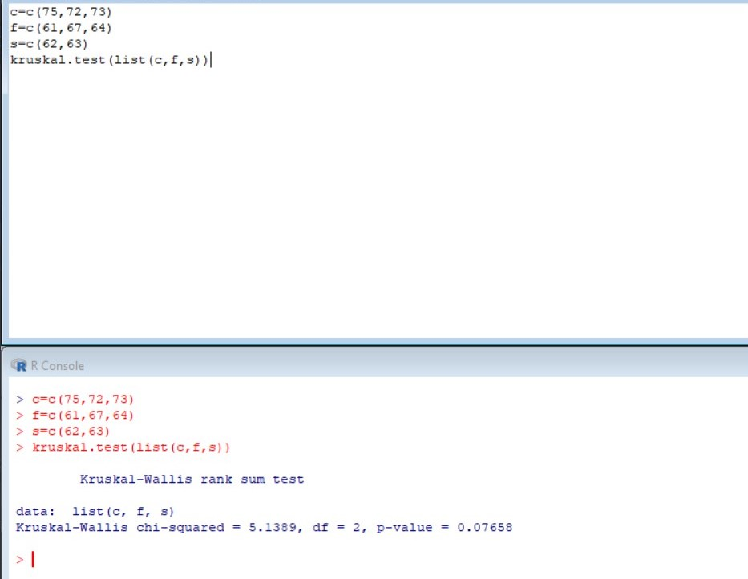

Q.2)The time taken to complete job on three machines are noted test the hypothesis that there is no significant difference between average time taken on these machines to complete the job

|  |  |
| --- | --- |
| Machine | Time taken in hrs |
| X | 2.9,3,2.5,2.6,3.2 |
| Y | 3.8,2.7,4.0,2.4 |
| Z | 2.8,3.4,3.7,2.2,2.0 |

**Solution:**

x=c(2.9,3,2.5,2.6,3.2)

y=c(3.8,2.7,4.0,2.4)

z=c(2.8,3.4,3.7,2.2,2.0)

kruskal.test(list(x,y,z))

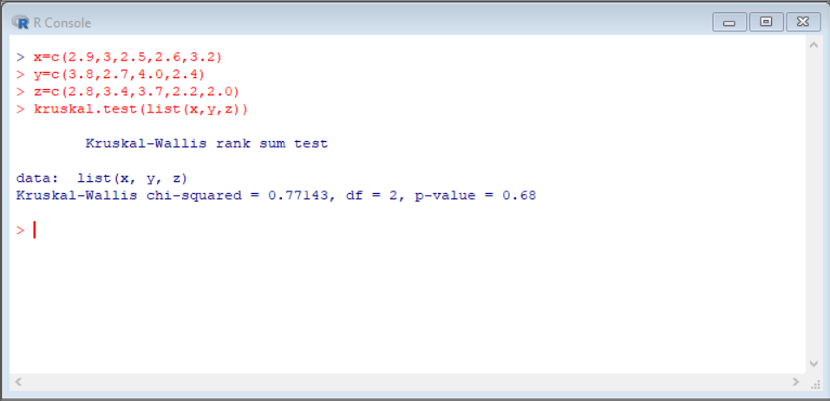**Output:**

Q.3)Carry out the analysis of variance for the following data

|  |  |
| --- | --- |
| **Varieties** | **Observations** |
| A | 50,52 |
| B | 53,55,53 |
| C | 60,58,57,56 |
| D | 52,54,54,55 |

**Solution:**

a=c(20,52)

b=c(53,55,53)

c=c(60,58,57,56)

d=c(52,54,54,55)

kruskal.test(list(a,b,c,d))

**Output:**

